ISWM South Atlantic Division
2026 Fall Meeting
October 2-3, 2026

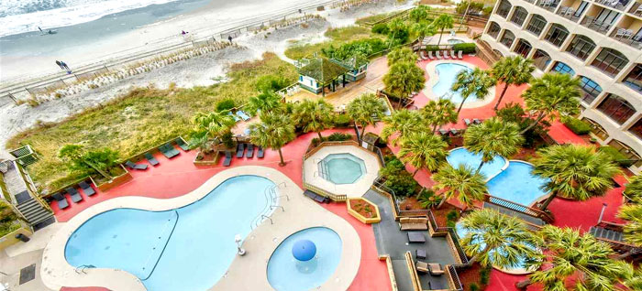
Beach Cove Resort
4800 S Ocean Blvd
N Myrtle Beach, SC 29582
(843) 286-5690

ROOM RESERVATIONS
Rooms must be reserved no later than September 1st to ensure availability and discount rate.
The fee for the first night’s stay is due at the time reservation is made.

Room Rates (includes tax and resort fee)
Oceanfront one-bedroom executive suite - $133.28
Oceanfront two-bedroom condo - $234.08
Oceanfront three-bedroom condo - $278.88
Call (888)974-5531 Refer to “ISW&M” to receive the discounted rate.

SPEAKERS

TBA


For additional information, contact:
ISWM South Atlantic Division
Sec./Treas. Bert Baxter
bbaxter@michelli.com
(864)244-4723
ISWM South Atlantic Division
2026 Fall Meeting
October 2-3, 2026

EVENTS
Friday, October 2nd

Welcome Reception with Vender Tabletop Display
Appetizers
6:00PM – 8:00PM

Rice Lake Weighing Systems Hospitality Suite
8:00PM – 11:00PM

Saturday, October 3rd
Annual Fall Division Meeting
Vendor Tabletop Displays
Registration 8:00AM
Meeting 8:30AM

Cocktail Hour 6:00PM

Buffet Dinner
Dancing with our very own DJ – The Fabulous T-MAC
7:00PM – 9:00PM

DOOR PRIZES
Visit every vendor table on Friday evening to be eligible for door prizes to be given away during the Saturday morning meeting! Each vendor will validate your vendor visitation card on Friday evening as you visit their table. Turn in your completed visitation card at the Registration Desk on Saturday morning. Cash and merchandise prizes will be awarded during the meeting on Saturday morning. You must be present to win.
ISWM South Atlantic Division
2026 Fall Meeting
October 2-3, 2026
Individual and Couple Registration Includes Friday Evening Functions, Saturday Meeting and Buffet Dinner
Individual Name:
Company:
Email:
$110 Registration
Couple Name/Guest:
Company:
Email:
$185 Registration

Vendor Tabletop Display $160 (In addition to registration fee). Limited to 12 due to available space.
Name:
Company:
Email:
Children 3 and under are free. Number:
Children Ages 4-12 $40 Each X =
Children/Quest 13 & Older $75 Each X =

Meeting Registrations are due by September 1, 2026
For Additional information or to register, contact:
South Atlantic Division
Sec./Treas. Bert Baxter
149 Landmark Drive
Taylors, SC 29687
bbaxter@michelli.com
(864) 244-4723
Make Checks payable to South Atlantic Division ISWM. Sorry, we cannot accept credit cards.

