2027 ISWM Annual Conference
Measured Impact: Driving Innovation, Automation and Sustainability
Exhibit/Sponsorship Application and Contract
Embassy Suites by Hilton | 11301 Financial Center Parkway | Little Rock, AR 72211
Phone: 310.345.5070
Please complete all applicable sections and return the signed form with payment.

Exhibitor Information
Company | Contact Name
Address
City / State / ZIP | Country
Telephone | Email

Registrant and Attendee Information
Primary registrant included with 8’ x 10’ booth: _____________________________________
Additional registrations are $300 each. Please use additional forms as needed.

Exhibit Fees
Select one exhibit space option.
Registrations received by January 15, 2027, qualify for a 10% discount.
Select | Exhibit Space | Included Registrations | Member Fee | Non-Member Fee
 | 8’ x 10’ | One full conference and exposition registration | $1,800 | $2,500
 | 16’ x 10’ | Two full conference and exposition registrations | $3,000 | $3,500

Total Exhibit Fee: ______________

Booth Selection
Select booth spaces as shown on the Expo Floor Plan (see document on last page). For availability, contact Ann Crowley at ann@iswm.org.
First choice: ______ Second choice: _______

Door Prize
Will you donate a door prize for the ISWM All Expo Card drawings? ____ Yes, ___ No

Sponsorship Opportunities
Select all sponsorship opportunities that apply.
Select | Sponsorship Opportunity | Amount | Notes
 | Platinum Sponsor | $2,000 | Premier Sponsor
 | Silver Sponsor | $1,000
 | Bronze Sponsor | $ 500
 | Copper Sponsor | $ 250
 | Coffee Break Sponsor | $1,000 | One day; two available
 | Wednesday Social Event Sponsor | $1,200

Sponsorship Total: $_______________

Payment Summary
Booth Fees Total | $
Sponsorship Total | $
Extra Attendees | $
Total Amount Due | $
Payment Method: ☐ Check enclosed, payable to ISWM in U.S. funds ☐ Credit Card

Credit Card Information
Credit Card Type  ☐ Visa | ☐ MasterCard | ☐ American Express
Account No. |  | Exp. Date | CVV
Name on Card
Cardholder Signature
I authorized ISWM to charge my credit card for the amount indicated above.

Authorization
By signing below, I certify that I am an authorized representative of the company listed on this application and have full authority to submit this application. The company agrees to comply with all policies, rules, and regulations contained in the Exhibitor Prospectus, including any updates adopted after publication.

Company
Authorized Name | Title
Signature | Date

Accommodation
Room rates at Embassy Suites by Hilton, 11301 Financial Center Parkway, Little Rock, AR 72211, are $159 per night Sunday through Thursday, plus taxes and fees. Parking is $6.00 per day. The group-rate reservation cut-off date is February 15, 2027. To make reservations, call 800-HILTONS and ask for the room block for the 2027 International Society of Weighing and Measurement Annual Convention or Copy and paste this link into your browser:
https://www.hilton.com/en/attend-my-event/international-society-of-weighing-and-measurement/

Please use the reservation code 93J to obtain the discounted rate and ensure your reservation counts toward ISWM’s room commitment. Annual Conference guests receive basic in-room Wi-Fi, cooked-to-order breakfast each morning, and an evening reception with beverages and hors d’oeuvres.

Cancellation Policy
Written cancellation notice must be received by February 15, 2027. A 25% service fee will be retained on all cancellations. No refunds will be issued after February 15, 2027.

Special Services
The International Society of Weighing & Measurement supports the Americans with Disabilities Act and promotes public accessibility. If you require special equipment or services, please attach a written description of your needs. We will contact you in advance to help ensure your needs are met.

Questions and Submission Instructions
Questions: Contact Ann Crowley at 715-651-9123 or ann@iswm.org.

Return signed application and payment to:
International Society of Weighing & Measurement
P.O. Box 296
Danville, IL 61834

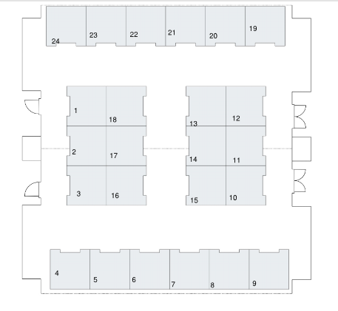
Entrance

