
Beyond Boundaries: Accelerating Scale through AI, Advanced Tech, and Best-In Class Operations

Come join the ISWM for updates on the Weighing and Measurement industry
Please join us to share ideas and hear the latest in the industry. The speakers are ready. Our industry is ready to continue evolving as technology and products change.
Sacramento is a city ready for visiting, tasting, and savoring. Features include farm-fresh restaurants, farmers markets, home-grown breweries, street murals, Gold Rush-era attractions or simply a walk along the river.
Join us March 10 through March 12, 2026, at DOUBLETREE BY HILTON HOTEL Sacramento, California.

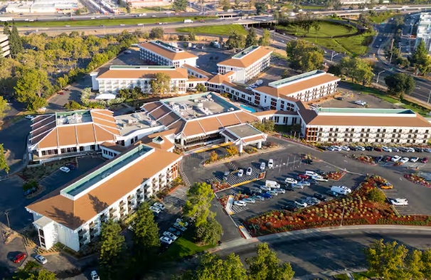

Hotel Information: Room rates at DOUBLETREE BY HILTON HOTEL SACRAMENTO, 2001 Point West Way
Sacramento, CA 95815, are $159 per night Sunday through Thursday plus taxes and fees. Parking is $12.00 per day.

The cut-off date for room reservations at the group rate at Doubletree is February 15, 2026. To make reservations guests may call: 800.HILTONS, group code ISWM or use booking link (CTRL enter): HiltonISWM_HyperLink

Please use the reservation code to obtain the discount and have your reservation count toward the ISWM’s commitment for room reservations. All ISWM Annual Convention guests will receive basic Wi-Fi in guest rooms and meeting space.

Travel Information: Sacramento International Airport is the nearest airport at 12 miles; Metropolitan Oakland International is 82 miles and San Francisco International Airport is 99 miles. The hotel does NOT have an airport shuttle.

Visa Information: Check with your local U.S. Embassy or Consulate regarding current Visa requirements. If you need a letter of invitation, please email Ann Crowley at ann@iswm.org.

Sponsorships:
Platinum: $2,000
• Recognized sponsor of the Conference and Expo’s Icebreaker Opening Reception. Sponsorship acknowledgment and appropriate signage at the Opening Reception of ISWM’s Conference and Expo.
• Prominence on all sponsorship listing/signage.

Gold: $1,500
• Recognized sponsor of the ISWM Conference and Expo.
• Prominence on all sponsorship listings/signage.

Silver: $1,000
• Recognized sponsor of the ISWM Conference and Expo.
• Listing on all sponsorship rosters/signage.

Bronze: $500
Listing on sponsorship rosters/signage

Copper: $250
Acknowledged at ISWM Conference and Expo

Coffee Break - $1,000 sponsorship for one day. Two sponsorships available. Who would not love the company that brought them a hot cup of coffee to combat the morning slump! Make your company the hero of the ISWM Conference as a Coffee Break sponsor at the Education sessions. You will be identified as the Coffee Break sponsor with signage bearing your company name and logo.
Wednesday Social Event Sponsor - $1,200 sponsor. You will be identified as the Wednesday Social Event sponsor with signage bearing your company name and logo. Also, your company will be acknowledged at the ISWM Conference and Expo.

Speakers:
Tuesday morning training March 10 (extra fee)
Mark Ruefenacht – Top Ten Balance & Scale Myths
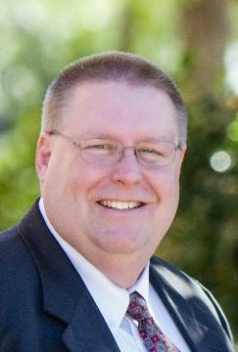
Mark Ruefenacht shares his time as a NIST associate with the Office of Weights & Measures (OWM) and as the Director of Precision Products at Rice Lake Weighing Systems. He specializes in teaching and developing metrology courses and standards that support State and industry laboratories across the United States and around the world. Drawing on his experience in precision measurement science, Mark creates practical, hands-on training that emphasizes both technical accuracy and real-world application. His work aims to help participants strengthen their processes, improve measurement confidence, and prepare the next generation of metrologists.

Presentation: “The Top Ten Balance & Scale Calibration Myths—Busted”
Join me for a fast-paced, myth-busting session where we unpack the ten most persistent misconceptions about balance & scale calibration and replace them with practical skills you can apply the very next day. Expect an energetic mix of examples, quick demos, and interactive polling as we debunk each myth—one at a time. Come for the myths—leave with a valuable toolkit of information. Participants who complete this session (attend all three hours while engaging in the polls and discussions) will receive a “Myth → Reality” Field Guide to share with their team. Bust myths with confidence!

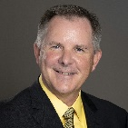
Don Onwiler – National Council of Weights and Measures Executive Director at National Conference on Weights & Measures update. Don was previously the Nebraska Division of Weights and Measures Program Manager. He served seven years on the NCWM Board of Directors and as chair in 2006. Don became the NCWM Executive Director in 2008.
Presentation: Updates from the National Council of Weights & Measures including changes to Handbook 44.

Mark Hilton, Founder – Ninja Concepts
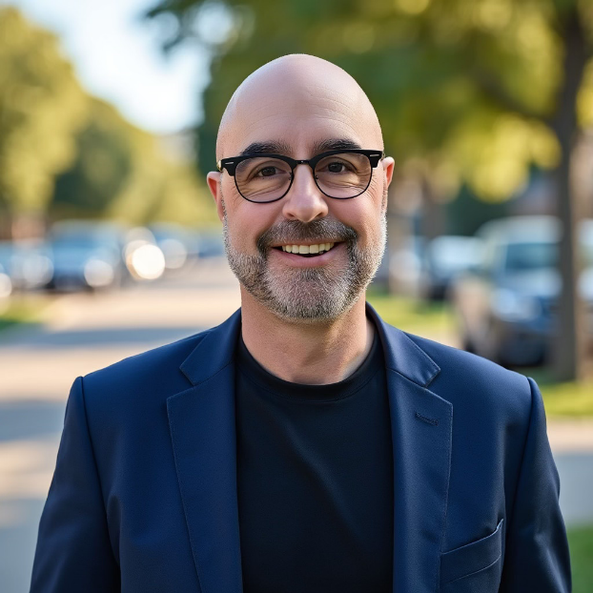
BIO: “After 35 years in the tech industry, I was tired of struggling to remember meeting details and action items yet constantly frustrated by tools that created more work than they solved.
I started Ninja Concepts because I believed there had to be a better way. Drawing on decades of experience seeing how technology can genuinely enhance everyday life, we set out to build simple, friction-less AI tools that solve real problems and give people back their most valuable resource: time.
For me, success means building solutions so useful they become second nature, tools our customers rely on every day. And if we can help people find better balance between work and life along the way, even better.”

Title:
"From Data to Decisions: AI That Works When Precision Matters Most"
Brief Description:
This presentation demonstrates how AI is transforming large-scale manufacturing operations through practical, deployable solutions that enhance accuracy, reduce downtime, and improve operational efficiency. Using Ninja Concepts' proven contextual AI technology, we'll explore how intelligent virtual assistants and AI-powered systems are helping manufacturers:
- Provide instant access to technical specifications, compliance data, and quality standards across complex product catalogs
- Reduce operational bottlenecks by delivering 24/7 expert-level support to floor staff and quality control teams
- Capture and standardize critical decision-making processes in real-time production environments
- Bridge the gap between experienced operators and new personnel through intelligent knowledge transfer
Through real-world case studies, including 40% reduction in customer wait times and successful deployment at high-pressure events—attendees will learn how contextual AI integration fits into existing manufacturing workflows without disrupting operations. This session focuses on practical implementation strategies specifically relevant to weights, measures, and precision manufacturing environments where accuracy and reliability are non-negotiable.

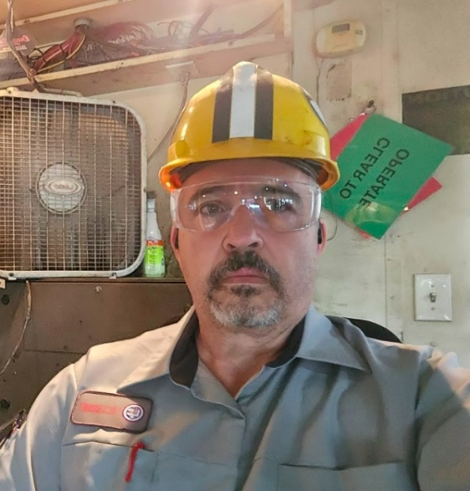
Lucian Stacy – Left Coast Scale: Lucian Stacy is a highly accomplished Regional Manager with over 30 years of experience in the weighing and measurement industry. He is currently the Regional Manager for Left Coast Scales LLC, where he oversees the Phoenix and Imperial Valley offices. His career includes a notable tenure as General Manager for Left Coast Scales, where he was integral to rebuilding operations and growing annual revenue from $250,000 to $4,000,000.

A co-founder of the company, Lucian also wrote and developed Left Coast’s training and professional development program. He holds a Bachelor of Science in Mechanical Engineering and is the Chair of the California Department of Food and Agriculture’s Registered Service Agency Advisory Commission. He is a frequent presenter and moderator at the ISWM National Conference.
Hazardous Area Classification: A Primer on the NEC System
Gain a clear understanding of the regulations and standards governing hazardous electrical installations in the United States with this essential presentation.
This primer provides a detailed look at the National Electrical Code (NEC) classification system for hazardous areas, covering the three ways locations are classified:
Type, Condition, and Nature¹.
You will learn about:
- The Regulatory Framework: Discover where U.S. regulations for explosion-proof and intrinsically safe equipment originate, focusing on the roles of OSHA, NFPA (NEC), ANSI, and the NRTL Program.
- NEC Hazardous Location Classes: Understand the three classes of hazards:
  - Class I: Flammable gases or vapors.
  - Class II: Combustible dusts.
  - Class III: Easily ignitable fibers or flyings.
- Condition of Hazard: Examine both the traditional Division System (Division 1 for normal operation, Division 2 for abnormal conditions) and the newer Zone System (Zone 0, 1, and 2).
- Equipment Design: Learn the critical differences between Intrinsically Safe equipment (limiting energy to prevent ignition) and Explosion Proof equipment (enclosures designed to contain an explosion).
-----------------------------------------------------------------------
Understanding the Role of the RSA Advisory Committee
This presentation offers an essential overview of the California Department of Food and Agriculture (CDFA), Division of Measurement Standards (DMS), Registered Service Agency (RSA) Advisory Committee.
The session will first establish the critical importance of the Weights and Measures system in California, detailing how the DMS oversees the accuracy and fairness of commercial devices like gas pumps and scales. We will then dive into the Registered Service Agency (RSA) Program, explaining what an RSA is, its licensing requirements, and its key function in expediting commerce across the state.
The core of the presentation focuses on the RSA Advisory Committee itself. Attendees will learn the Committee's official mandate—to formally advise the CDFA/DMS Secretary on all RSA Program matters—and its broad scope, which includes contributing vital industry input to the rulemaking process, reviewing enforcement policies, and addressing the technical challenges of new measuring technologies (like ZEV devices).
Finally, we will discuss the powerful impact of the Committee, highlighting why its input is crucial for licensed RSAs, Service Agents, and the regulatory bodies they work with. This is a must-attend session for industry members seeking to understand how to influence and engage with the governing structure of the California weights and measures service industry.
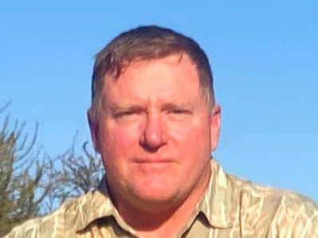
Troy Basnet, Phillips Scales– Troy Basnett is Operation Manage at Phillips Scales in Alaska. He has over 34 years of diagnostics experience from military and civil aviation aircraft, heavy equipment, and vehicles and for over twelve years on weighing devices. Phillips Scales is a different operation than most scale companies due to logistics in operating in Alaska. The average vehicle milage for smaller trucks is around 5000 and large capacity is under 3000 miles per year. Technicians fly to many jobs within and outside the state and deal with extreme weather conditions. Additionally, in the summer technicians can be found bouncing on and off fishing vessels for major fishing companies getting ready for various species. Troy brings many years of experience as a technician and operations manager to his understanding of the scale business.
Presentation Description: Follow the power. A primer on quickly diagnosing issues with weighing devices in the scale industry.

Methodical Diagnostics Training-When a technician is faced with a problem, how does he approach finding a solution. Understanding troubleshooting methodology in scales is crucial and will help resolve issues efficiently. This approach will save time and enhance critical thinking skills.

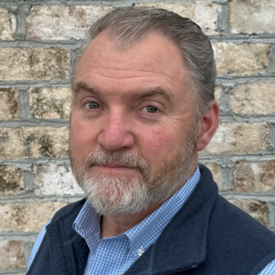
Matt Miller, President and CTO of MobileDemand - Revolutionizing Warehouse Workflows: Mobile Scaling & Real-Time Product Data with xScale S200

Bio: Matt Miller founded MobileDemand in 2003. In 2016, Miller founded 4DMobile, a companion company offering software solutions for MobileDemand's line of rugged tablets focusing on computer vision and artificial intelligence geared toward improving logistics workflows. Miller is a technologist with a passion for bringing products to market, utilizing extensive sales and marketing experience and skills as well.

Description:
Discover how the xScale S200 Bluetooth mobile scale transforms warehouse operations by combining convenience, mobility, and error-free data capture. In this session, we’ll explore how real-time weight and product item data collection at the point of handling eliminates manual entry mistakes, accelerates workflows, and improves accuracy across your operations. Learn how seamless integration with mobile apps empowers your team to capture, verify, and utilize product information on the spot—redefining efficiency from receiving to shipping
🔑 Key Takeaways
- Mobile Scaling on the Spot – Weigh items directly on the warehouse floor for faster workflows.
- Instant App Integration – Bluetooth® connects weight data to application instantly.
- Error-Free Data Capture – Reduces manual entry mistakes and improves inventory accuracy.
- Durable & Portable – Rugged design meets warehouse demands, easy to carry or wear.
- All-in-One Product Capture – Combine weight, dimensions, barcodes, and photos in a single workflow.

Two RoundTable presentations:
Manufacturer’s Roundtable and Dealer’s Roundtable
Extremely popular presentation involving discussion of events affecting Dealers and/or Manufacturers. Key input from both groups and highlighting different viewpoints from around the country.

Dealer Survey Results - Presentation of the results of our bi-annual survey. Survey results include average income for scale company employees, growth/loss in the business, business profitability any many other topics.

Exhibit Information:
The exhibit set up will begin on March 10 at 10 am. All Exhibits need to be removed by 7:00 pm on Thursday, March 12. All equipment shipped should be marked with the name and date of the Conference. All equipment crates or material needs to be on wheels. The hotel cannot move the crates as there is no pallet jack on the property. There is no storage space for crates on the site. Equipment should arrive no sooner than 2 days before the conference (Sunday 3/8/2026). All boxes must be removed by the day after the conference.

All shipments are to be delivered to:
DOUBLETREE BY HILTON HOTEL SACRAMENTO
International Society of Weighing & Measurement Conference
2001 Point West Way
Sacramento, CA 95815

The exhibit tables are one six-foot table with cloth skirting, two chairs, and a wastebasket. There will be 16 8’x10’ spaces available.

Call for Nominations for Awards: (Nominations to be completed by January 15, 2026.)

Mark Pickell Award:
Recognizing and honoring that member whose outstanding activities and efforts during the preceding year (or years) has contributed to strengthening the effectiveness, benefits, and growth of his/her local Division of ISWM. In memory of Mark W. Pickell, who was associated with the weighing industry and NSMA from the early publication days of Scale Journal (now Weighing and Measurement Magazine). Mr. Pickell served as Secretary-Treasurer of NSMA for years.

Purpose - The Mark Pickell award was created to recognize and honor that member whose outstanding activities and efforts during the preceding year (or years) has contributed to strengthen the effectiveness, benefits, and growth of his/her local Division of ISWM.

Eligibility Requirements
The candidate must be a member of the Division in good standing, placing the nomination for at least one year. The candidate must be active in his/her division affairs during the year in which he/she is nominated, regularly attend meetings, and help when asked.

The candidate does not have to be active on an international level, nor present at the society Conference. The candidate may not be nominated by his/her division for another international award in the same year. Candidates may be nominated more than once, but not in two consecutive years.

Lady of the Year Award:
To encourage active participation in the Society on the part of wives of members and the women in the weighing industry, and to recognize their valuable contributions to the Society and the industry.
Sponsored by a trust fund in care of ISWM set up in 1979 by Raymond C. and Charlotte M. Canfield, Pittsburgh, PA.

Purpose - To encourage active participation in the Society on the part of wives of members and the women in the weighing industry and to recognize their valuable contributions to the Society and the industry.

Eligibility Requirements
The candidate should be a member of the International Society of Weighing and Measurement or the wife of a member in good standing. The candidate should be present at the Society Conference. The candidate must participate in the guest program seminar and at least one other guest program activity during the conference; or be registered as a conference attendee. The candidate shall have been active in ISWM Division and District activities. Consideration also will be given for participation in activities of her church, her community, and other outside organizations. Paid staff members of ISWM will not be eligible for this award.

Nominations
Each Division may submit at least one nomination for the award, and more than one may be submitted. Nominations shall be sent to the ISWM headquarter office no later than thirty (30) days prior to the Society Conference and shall be no more than two pages in length. Nominations shall include pertinent information on the activities and achievements of the candidate in ISWM, in her community, church, and other outside organizations.

Woody Woodland Memorial Award:

This award is intended to honor a person who, by his/her own efforts and services, has contributed in an outstanding manner to the scale and weighing industry. In Memory of J.E. "Woody” Woodland, who dedicated his entire life to the weighing industry and to the people in it, and who passed away in 1948 on the day he was elected President of National Scale Men’s Association.

Purpose - The award is intended to honor a person who, by his/her own efforts and services, has contributed in an outstanding manner in the scale and weighing industry.

Nominations - Each Division of the Society is asked to submit a nomination to the Chairperson of the nominations committee.

Outstanding New Product Award (Kardux Cup)

Recognizing a company, group, or individual for the most outstanding new technical achievement of the last year that positively impacts the weighing and measurement industry. Established in 1996, the Outstanding New Product Award (Kardux Cup), is sponsored and funded by the International Society of Weighing and Measurement. Named for Ken Kardux, of Kg Systems, Inc. whose inspiration was instrumental in the implementation of the award, and who generously contributed funds towards the purchase of the original perpetual trophy.

Purpose
To recognize a company, group, or individual for the most outstanding new technical achievement in the last year that positively impacts the weighing and measurement industry.

Award Process
The Outstanding New Product Award selection committee shall consist of the First Vice President as Chairperson. The Chairperson will select members. The members shall be selected from a cross section of the Weighing and Measurement industry, such as manufacturers of scales, load cells, indicators, printers, and components, wholesale distributors, dealers, users, regulators, inspectors, and government officials. The committee will meet during the Society Conference and review all products and documents submitted. The committee will choose three finalists, and interview each of the finalists. The committee will inform the three finalists of the date and time the award will be presented and encourage them to attend the event. Once the interviews have been completed, the committee will meet and come to a majority decision on the winner.

Eligibility Requirements
1. Product data, picture, and application is to be submitted 30 days before the Society Conference. This information will then be distributed to committee members.
2. Admission to the New Product Showcase will be granted only to current exhibitors.
3.The product must have been released for publication or use during the last year.
4.Achievement must represent a significant technical advancement.

Most Outstanding Exhibit Award
Recognizing a company that exhibits at the Society Conference for having the most outstanding exhibit.

Purpose -To recognize a company that exhibits at the Society Conference for having the Most Outstanding Exhibit.

Eligibility Requirements - The recipient must be exhibiting at the current Society Conference. The exhibit will be judged on overall quality, product presentation, booth staffing, personal appearance, helpfulness to attendees, and assistance with technical and application questions.

Conference & Expo Attendee Registration Form

Location of 2026 ISWM Annual Convention:
DOUBLETREE BY HILTON HOTEL SACRAMENTO
2001 Point West Way
Sacramento, CA 95815
Phone: 916.924.4912

Conference Registrant (please print – Only ONE Registrant Per Form)
Name: _________________________________ Nickname (to appear on badge): ________________
Firm: ____________________________________________________
Address: _________________________________________________
City: _______________ State: _____________ Zip: ________ Country: ____________
Telephone: ___________________________ Email: __________________________________

Employee Classification:
Please check the category that best describes your business:
W&M Industry Manufacturer Consumer
W&M Industry Dealer/Distributor Regulatory Official
Retired Importer/Exporter

Registration Packages
Full Conference: Registration Includes admission to the Icebreaker Reception, Educational Program, Expo, Wednesday Social Event, and lunch on Wednesday and Thursday. $350.00
One-Day Registration Includes admission to Icebreaker Reception on Tuesday evening, the Opening General Session, One-Day Expo, and lunch on Wednesday or Thursday. $ 200.00
Wednesday or Thursday
Tuesday-Special Mark Ruefenacht training – Myths of Balances & Scales $99.00

Registration Fees (Please Circle choice): NOTE: 10% discount if register by January 30, 2026

Member Non-Member
Full Conference Registration $350 $400
Myths of Balances & Scales Training $ 99 $ 99
One Day Registration: (Wednesday or Thursday) $200 $250

Payment: ￼TOTAL AMOUNT DUE $____________________

Check enclosed (payable to ISWM, US funds only) Check No: _______

Credit Card: ￼ VISA Master Card American Express
Account No: ______________________________ Exp Date: ____________CCV______
Name on Card: ____________________________________
Signature: ________________________________________
I authorized ISWM to charge my credit card for the amount indicated above.

Accommodations:
Room rates DOUBLETREE BY HILTON HOTEL SACRAMENTO, 2001 Point West Way, Sacramento, CA 95815, are $159 per night Sunday through Thursday plus taxes and fees. Parking is $12.00 per day. The cut-off date for room reservations at the group rate at Doubletree is February 15, 2026. To make reservations guests can call: 800-HILTONS and use code ISM or use booking link (CTRL click): HiltonISWM_HyperLink

Please use the reservation code to obtain the discount and your reservation counts toward the ISWM’s commitment for room reservations. All ISWM Annual Convention guests will receive basic Wi-Fi in guest rooms and meeting space

Special Services:
The International Society of Weighing & Measurement supports the Americans with Disabilities Act, which promotes public accessibility for people with disabilities. If you require special equipment or services, please attach a written description of your needs. We will contact you in advance to ensure your needs are met.

GOT QUESTIONS?
Contact Ann Crowley for answers:
Phone: 715-651-9123
Email: ann@iswm.org

EXHIBIT/SPONSORSHIP APPLICATION

AND CONTRACT

Location for 2026 ISWM Annual Conference:
DOUBLETREE BY HILTON HOTEL SACRAMENTO
2001 Point West Way
Sacramento, CA 95815

Exhibitor:
Company Name: ___________________________________________________
Contact Name: ____________________________________________________
Address: _________________________________________________________
City: ___________ State: _______________ Zip: ________ Country: ________
Telephone: _____________________ Email: ___________________________

Other Registrant or Attendees: (one with 10’ x 10’)
Name registering: ______________________________________

Extra Registration (use extra forms) - $350 each.

Fees:
The exhibit space will be rented according to the following fee structure (check one): 10% discount if register by January 30, 2026.
Members Non-Members
8’ x 10’ Includes one (1) full Conference and $1,800 $2,500
Exposition registration
16’ x 10’ Includes two (2) full Conference and $3,000 $3,500
Exposition registrations

TOTAL FEE $ ________________

Selection:
Select space as shown on the Expo Floor Plan (Contact Ann at ann@iswm.org for available space) . List only one number per choice. 1st choice ________ 2nd choice __________

Promotions:
Describe in 50 words or less (exactly as you want it to appear in the official promotions) the products, or the services you will be exhibiting. Attach a description to this application or email Ann Crowley at ann@iswm.org.

Sponsorship: Please indicate your sponsorship level:
Premier Sponsor: ___ Platinum - $2,000 ___ Gold - $1,500 ___ Silver - $1,000
Coffee Break Sponsor: ____ One Day - $1,000 (2 available)
Wednesday Social Event Sponsor: ____ $1,200

SPONSORSHIP TOTAL: _________________

Door Prize:
Will you donate a door prize for the ISWM All Expo Card drawings? ___ Yes ___ No

Payment:
Booth Fees Total: _____________________
Sponsorship Total: _____________________
Extra Attendees: $____________________
TOTAL AMOUNT DUE $____________________
Check enclosed (payable to ISWM, US funds only) Check #__________

Credit Card: VISA Master Card American Express
Account No: _________________________ Exp Date: __________________CCV:____
Name on Card: ____________________________________
Signature: ________________________________________
I authorized ISWM to charge my credit card for the amount indicated above.

Authorization:
I am an authorized representative of the company with full power and authority to sign and deliver this application. The company listed on this application agrees to comply with all policies, rules, and regulations contained in the Exhibitor Prospectus and all policies, rules, and regulations adopted after publication of the prospects, which we accept as part of the agreement.
Company: ___________________________________________________
Authorized Name: ___________________________ Title: ___________________
Signature: ___________________________________ Date: ___________________

Accommodation:
Room rates at DOUBLETREE BY HILTON HOTEL SACRAMENTO, 2001 Point West Way
Sacramento, CA 95815, are $159 per night Sunday through Thursday plus taxes and fees. Parking is $12.00 per day. The cut-off date for room reservations at the group rate at Doubletree is February 15, 2026. To make reservations guests can call: 800-HILTONS and use group code ISM or use booking link (ctrl enter): HltonISWM_MotelLink,

Please use the reservation code to obtain the discount and your reservation counts toward the ISWM’s commitment for room reservations. All ISWM Annual Convention guests will receive basic Wi-Fi in guest rooms and meeting space.

Cancellation Policy:
A written cancellation notice is required and must be received in writing by February 15, 2026. A 25% service fee will be retained on all cancellations. No refunds will be given after February 15, 2026.

Special Services:
The International Society of Weighing & Measurement supports the Americans with Disabilities Act, which promotes public accessibility for disabled people. If you require special equipment or services, please attach a written description of your needs. We will contact you in advance to ensure your needs are met.

GOT QUESTIONS?
Contact Ann Crowley for answers:
Phone: 715-651-9123
Email: ann@iswm.org

Return signed application and payment to:
International Society of Weighing & Measurement
P.O. Box 296, Danville, IL 61834
PH: (715) 651-9123
Email: ann@iswm.org

